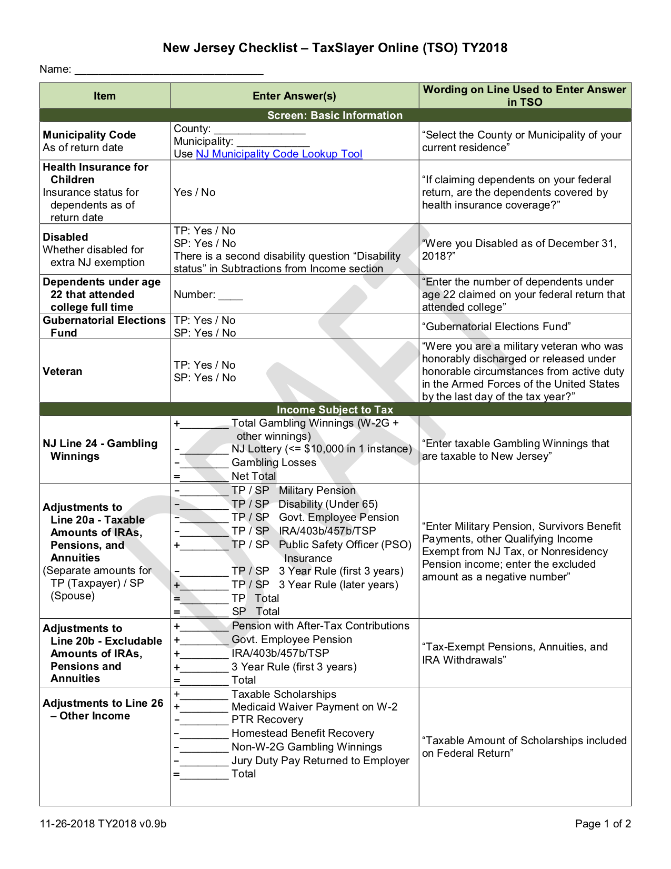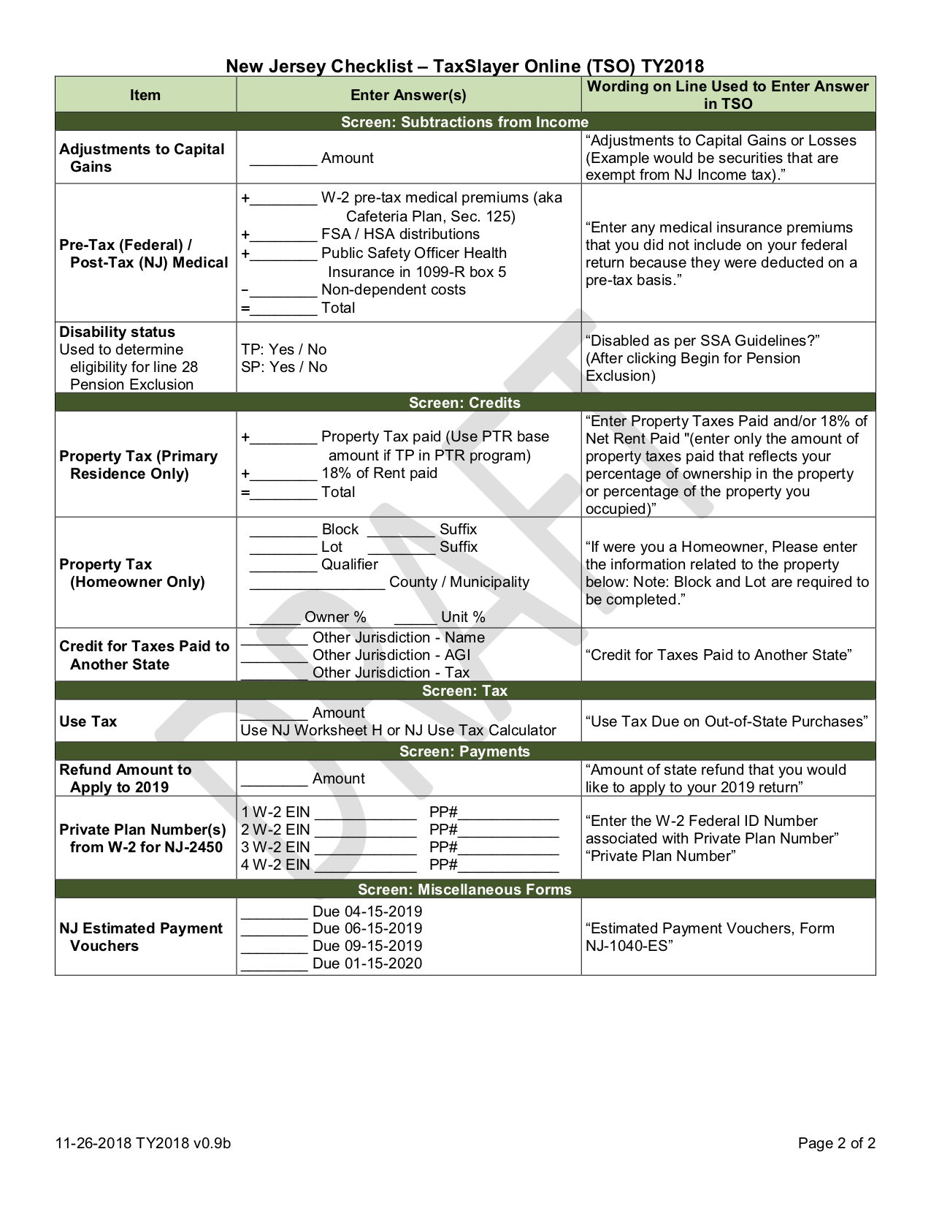

Bickle NJ Checklist v1.0 12-16-2019

0

Bickle

Somerset

Bedminster Township

-350

350

See ScratchPad

for calculation

Bickle NJ Checklist v1.0 12-16-2019

1,620

1,620